Routing Report
Student Name
Institution Name
Date

Routing protocols are utilized to enable the relay of routing information between routers. They are basically a set of processes, procedures and messages used in exchanging routing information as well as updating the routing table with the protocols choice of the best paths.
Provide a list of meaningful questions that you prepared for the meeting with the client in order to clarify the requirements and a rationale showing your understanding and interpretation of the requirements.
Questions
Cost
IP ADDRESSES/CONFIGRAION USED for the network
Types of network devices
Router configurations
Number of users
Number of host devices
Number of networks – which will determine the number of subnets

IP Addressing Scheme

WATFORD
Device | Interface | IP Address | Subnet Mask | Default Gateway
DNS Server | FE0 | 8.8.8.8 | 255.0.0.0 | 8.8.8.7
ISP Router | FE0/0 | 8.8.8.7 | 255.0.0.0 | N/A
ISP Router | S0/0 | 200.200.200.2 | 255.255.255.252 | N/A
1st Floor (Management and Engineering)
Router WATFORD_1 | FE0/0 | 192.168.1.37 | 255.255.255.252 | N/A
Router WATFORD_1 | FE0/1 | 172.16.9.6 | 255.255.255.0 | N/A
Router WATFORD_1 | S0/0 | 200.200.200.1 | 255.255.255.252 | N/A
Router WATFORD_1 | S0/1 | 192.168.1.33 | 255.255.255.252 | N/A
Router WATFORD_1 | E1/0 | 172.16.10.132 | 255.255.255.224 | N/A
Ground Floor
Router WATFORD_2 | FE0/0 | 192.168.1.38 | 255.255.255.252 | N/A
 | FE0/1 | 172.16.8.5 | 255.255.255.0 | N/A
 | E1/0 | 172.16.10.6 | 255.255.255.0 | N/A
STEVENAGE
2nd Floor (Marketing)
Router STEVENAGE_1 | FE0/0 | 192.168.2.10 | 255.255.255.240 | N/A
Router STEVENAGE_1 | FE0/1 | 192.168.1.17 | 255.255.255.248 | N/A
Router STEVENAGE_1 | S0/0 | 10.0.0.11 | 255.255.255.0 | N/A
1st Floor (HR)
Router STEVENAGE_2 | FE0/0 | 192.168.2.71 | 255.255.255.240 | N/A
Router STEVENAGE_2 | FE0/1 | 192.168.1.73 | 255.255.255.240 | N/A
Router STEVENAGE_2 | E1/0 | 10.0.0.69 | 255.255.255.240 | N/A
Ground Floor
(Server Farm)
Router STEVENAGE_3 | FE0/0 | 192.168.1.86 | 255.255.255.252 | N/A
Router STEVENAGE_3 | FE0/1 | 10.0.0.83 | 255.255.255.240 | N/A
Server0 | FE0 | 10.0.0.81 | 255.255.255.248 | 10.0.0.94
 | FE0 | 10.0.0.82 | 255.255.255.248 | 10.0.0.94

Dynamic routing protocols are used in discovering the remote network, keeping up to date routing data, finding a new best path if the existing path is no longer available, and, choosing the most appropriate path to destination networks.
Components of dynamic protocol routing.
Routing protocol messages - uses several types of messages to discover neighboring routers.
Data structures that utilizes database for its operations (information kept in RAM)
Algorithms, a procedure with detailed list of steps taken to accomplish a given operation.
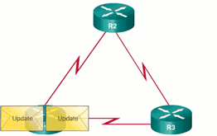
Static routing protocols is used in providing ease of routing database table maintenance in small networks that are not to grow to a greater extent, routing to and from a stub network, meaning a network that has only one default route and no knowledge of remote networks, and, accessing a single default route.
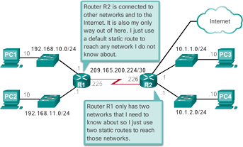
InterVLAN routing is operated by connecting various physical router interfaces to different physical switch ports. The switch ports connected to the router are placed in access mode, and each physical interface is assigned to a different VLAN. Each router interface can then accept traffic from the VLAN associated with the connected switch interface, and the traffic can be routed to other VLANs connected to the other interfaces.
Network traffic monitoring is the process of reviewing, analyzing, and managing network traffic for any abnormalities or processes that affect network performance, availability, and / or security.
Network traffic management handles the process of monitoring and controlling the network's operations while transforming the network into a managed resource by improving efficiency, efficiency and security. It enables network systems to operate, manage and maintain network settings.

An explanation of router configuration on both sides, and commented screenshots of testing the connections on Packet Tracer Simulator command line option. For reporting on router configuration, just copying and pasting some commands is not enough. The syntax of the commands can change from one platform to another and from one manufacturer to another. It is the process that needs to be explained. You will be using Cisco router commands to explain configuration steps that can otherwise be done on any other types of routers but just with different syntax. As you will need to do some research about routing protocols, you need to use Harvard referencing to cite your sources.
Routue Configurations
 | Command | Purpose
Step 1 | configure terminal  Example:  Router> enable  Router# configure terminal  Router(config)# | Enters global configuration mode, when using the console port.  If you are connecting to the router using a remote terminal, use the following:  telnet router name or address  Login: login id  Password: *********  Router> enable
Step 2 | hostname name  Example:  Router(config)# hostname Router  Router(config)# | Specifies the name for the router.
Step 3 | enable secret password  Example:  Router(config)# enable secret cr1ny5ho  Router(config)# | Specifies an encrypted password to prevent unauthorized access to the router.
Step 4 | no ip domain-lookup  Example:  Router(config)# no ip domain-lookup Router(config)# | Disables the router from translating unfamiliar words (typos) into IP addresses.

Practical
The given instructions and there being no specific IP addressing system given.
I developed a random set of IP addresses for the pcs, switches, routers, and servers.
The IPS assigned is easy to relate and coordinate to avoid stressing during the follow-up.
In the topology entails a combination of pcs connected to switches, switches to routers, routers to routers, and routers to the server and router to the DNS server.
The connectivity can be tested through pinging the different tips from different points such as the pc and the switch/router.
Through the naming system used, the names are mostly the assigned IP addresses used in this topology but the rest of the configurations can be checked in the IP configurations of the different devices used.
Watford set up.
In this set up I have used static and defaulting routing, default routing mostly implemented in the pcs and routers. Also have used rip version 2 configurations in the routers to help define the networks in the association as specified in the configurations.
The same instance case is used on the Stevenage set up.
The ripv2.
To configure this in a router you need to specify the interface the rip will be implemented in, the different networks connected to this router, and also have the router well configured even the clock rate specified. We also need to specify version 2 of rip otherwise the rip will by default be version 1.
The security feature used in this topology is ACLs which restrict access to different sites.
The configurations running in the router connected to the DNS server are the ones restricting access, they include the permit and deny then specifications of the different sites.
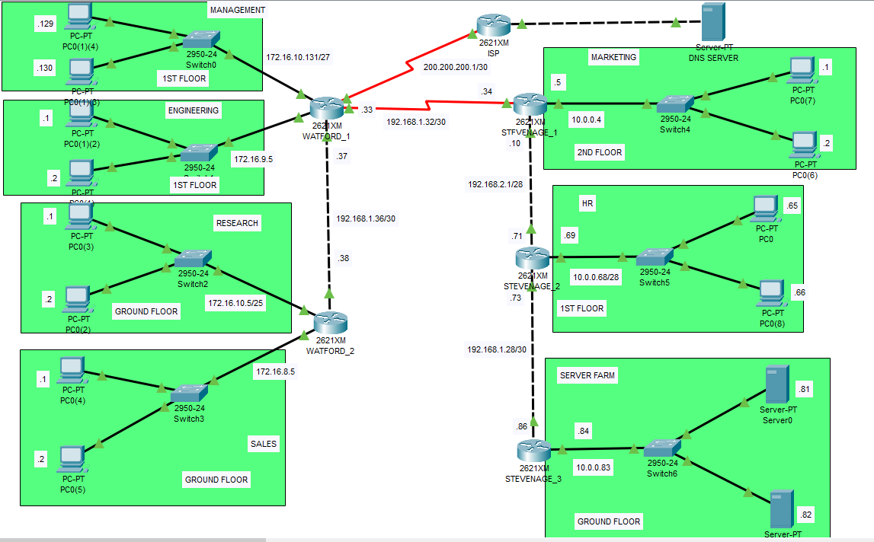

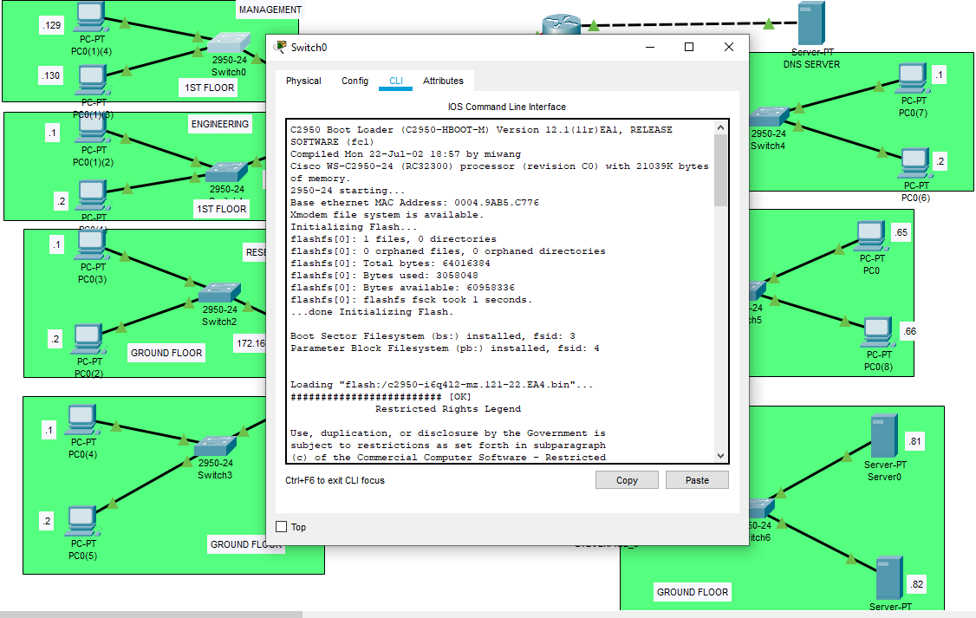

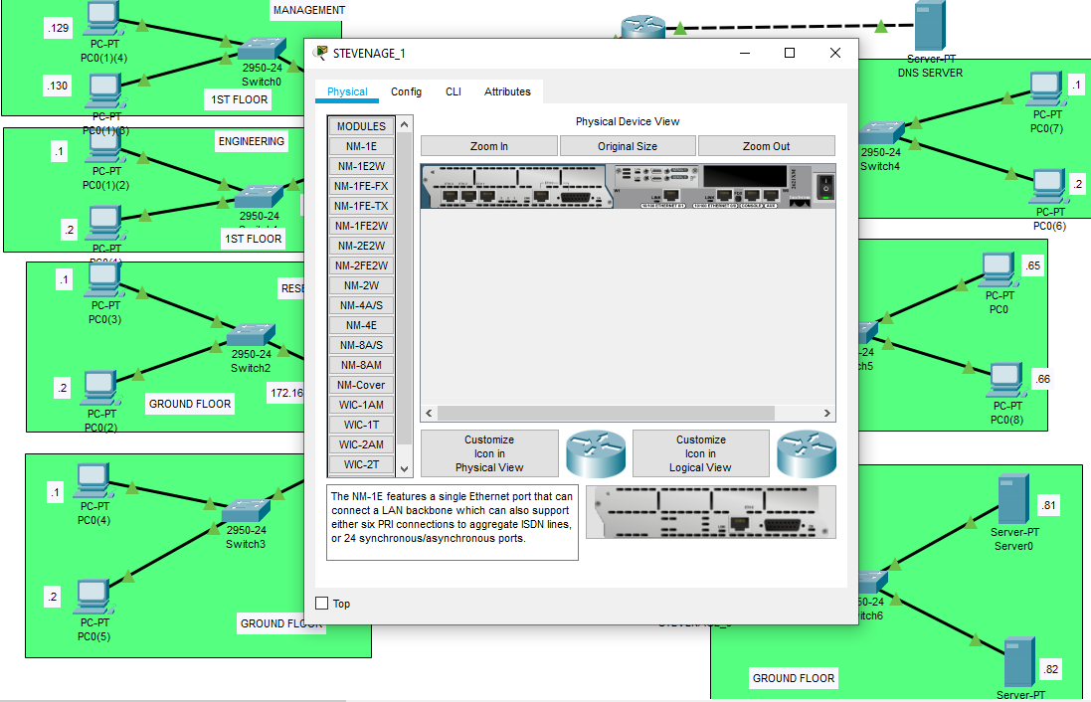

Recommendations
(Paul, J., Agatz, N., Spliet, R., & De Koster, R. 2019), Security architects must consider the overall infrastructure layout, including segmentation and segregation. Proper network segmentation is an effective security mechanism to prevent an intruder from propagating exploits or laterally moving around an internal network.
Implement principles of least privilege and need-to-know when designing network segments.
Separate sensitive information and security requirements into network segments.
Apply security recommendations and secure configurations to all network segments and network layers.
Use private Virtual Local Area Networks (VLANs) to isolate a user from the rest of the broadcast domains. Use virtual routing and forwarding (VRF) technology to segment network traffic over multiple routing tables simultaneously on a single router. Use Virtual Private Networks (VPNs) to securely extend a host/network by tunneling through public or private networks.

References
https://www.ipv6.com/applications/network-traffic-management/
https://www.ciscopress.com/articles/article.asp?p=2180210&seqNum=5
https://www.cisco.com/c/en/us/support/docs/lan-switching/inter-vlan-routing/41860-howto-L3-intervlanrouting.html
Al-Baghdadi, A., Lian, X., & Cheng, E. (2019). Efficient Path Routing Over Road Networks in the Presence of Ad-Hoc Obstacles (Technical Report). arXiv preprint arXiv:1910.04786.
Gansterer, M., & Hartl, R. F. (2020). Shared resources in collaborative vehicle routing. TOP, 1-20.
Paul, J., Agatz, N., Spliet, R., & De Koster, R. (2019). Shared Capacity Routing Problem− An omni-channel retail study. European Journal of Operational Research, 273(2), 731-739.

